# Q1. [10 points] Give asymptotic upper and lower bounds for T(n) in each of the following recurrences. Assume that T(n) is constant for n ≤ 3. Make your bounds as tight as possible, and justify your answers. (Hint: You can use the best matching case of Master Method to determine the tight bounds of Θ notation)

# T(n) = 2T(n/3) + n lg n

# T(n) = 3T(n/5) + lg2 n

# T(n) = 7T(n/2) + n 3

# T(n) = T(√𝑛) + Θ(lg lg n)

# T(n) = 10T(n/3) + 17n 1.2

# Q2. [5 points] By using the substitution method, show that the solution of the recurrence T(n) = T(n-1) + n is O(n 2 ). (Exercise 4.3-1)

# Q3. [5 points] Use a recursion tree to determine a good asymptotic upper bound on the recurrence T(n) = T(n/2) + n 2 . You can use the substitution method to verify your answer. (Exercise 4.4-2)

# Q4. [5 points] Use Strassen’s algorithm to compute the matrix product and show your work. (Exercise 4.2-1)

( 1 3 ( 6 8

7 5 ) 4 2 )

Output from the PA1 code:

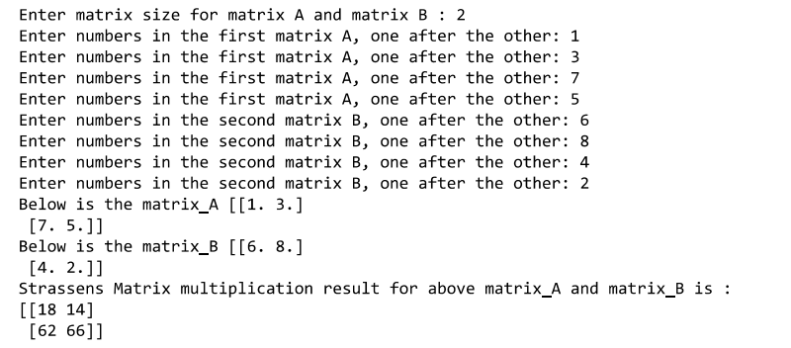

Validation:

